Stuart Parks Forensic Associates Presents

Digitally Assisted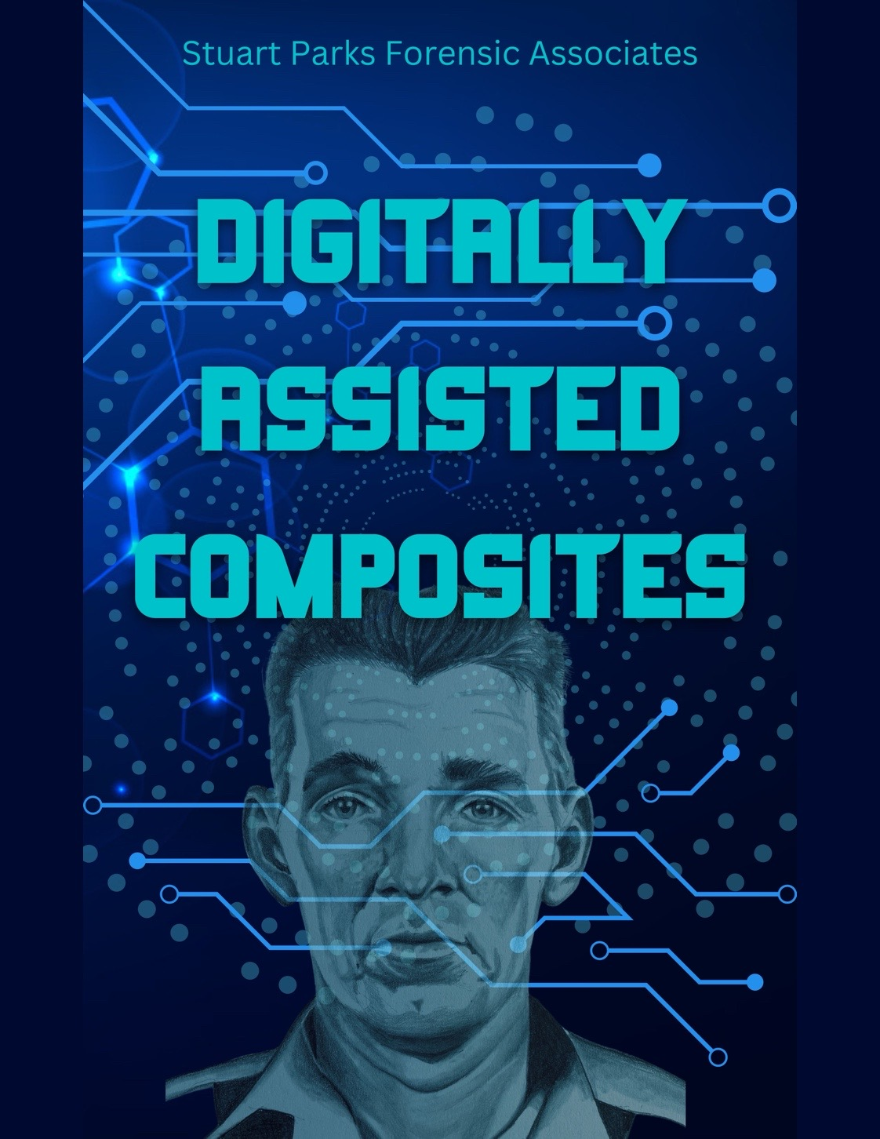 Composites

Announcing a 40-hour class in digitally assisted composite art.

**September 22-26, 2025**

San Diego, California

**Information:** This workshop is designed to train individuals in the utilization of the digital drawing program Procreate in conjunction with traditional drawing skills, materials, and previous training in composite art. This offers another, potentially faster, option to create technically-sound drawings to be used in the field of forensic art.

The 40-hour workshop is open to **Certified Composite Artists only. This class applies to the Certified Forensic certificate.**

Class size is very limited. Only a maximum of 10 participants may attend. Students will have a dedicated instructor for this class (see below.)

Participants must bring their own iPad with the Procreate app uploaded and an Apple Pencil. Complete list of requirements and supplies attached.

**Instructors**: Carrie Stuart Parks and Michelle Garlock

**Michelle Garlock**, CCA, CFA, has been an associate instructor for Stuart Parks Forensic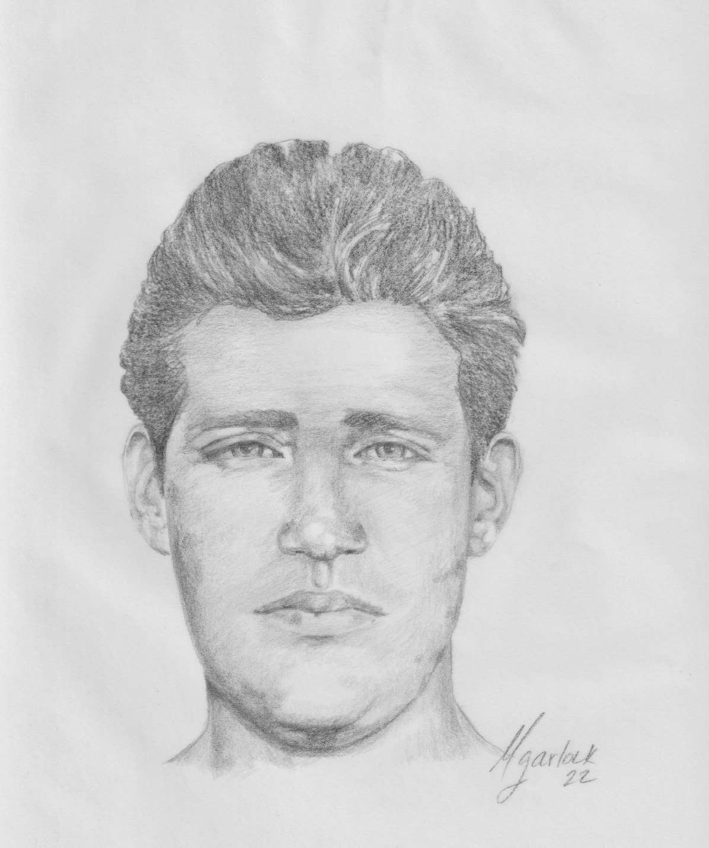 Associates since 2013. She received her BS in Art Therapy from the College of New Rochelle and her Masters in Educational Administration from the State University of New York at Brockport. She has a Certificate of Advanced Studies in Educational Administration from the State University of New York at Brockport. She has studied in Italy and France with award winning artists in the field of decorative painting. She received “Teacher of the Year” from All Women Rock (AWR) of Rochester, NY.

**Enrollment information:** $1195. Fee includes workbook, handouts, and some drawing tools and equipment. For more information and to enroll: Carrie Stuart Parks, Stuart Parks Forensic Consultants, P.O. Box 73, Cataldo, ID 83810. (208) 682-2831. You may enroll by email or phone call. Credit card or check.

**Required for class:**

* **iPad: Although you can bring any iPad capable of utilizing an Apple Pencil, screen size at least 10.9”, at least 64GB, and set up for Wifi, the best iPad for the course is the 12.9 iPad Pro.**
* **Power cord for above iPad.**
* **Apple Pencil.**
* **Procreate program downloaded on your iPad (found in the App Store).**
* **Upon enrollment and payment, participants will be given a web page with the downloads on it.**

**Provided:**

* **Bag:** Stuart Parks provided carrying bag.
* **Pouch:** Stuart Parks provided pencil case.
* **Paper:** Stuart Parks provided Drawing paper-Clearprint vellum.
* **Mechanical Pencil**.
* **6” ruler**

**Please bring:**

* FBI book.
* Drafting tape.
* Circle template.
* Erasers: misc. white plastic.
* Kneaded eraser.
* Pad of Bristol paper.
* Pad of tracing paper.
* Small pair scissors.
* Drawing pencils
* Any additional drawing tools you wish to bring.

**Optional:**

MOBDIK paper feel screen protector (be sure to get the size for your iPad!)

OTralo glove.

Case that holds and charges Apple Pencil. Recommended case Ztotop case. Be sure you get the correct size for your iPad.

**Enrollment**

**Forensic Classes**

**Stuart Parks Associates**

|  |  |  |  |  |  |  |
| --- | --- | --- | --- | --- | --- | --- |
| 1. Class   Information | Date:  Location: |  | | | | |
| 2. Attending  Information | Full Name |  | | | | |
| Department: |  | | | | |
| Address: |  | | | | |
| City, State, |  | | | | |
| Zip: |  | | | | |
| Work phone: |  | | | | |
| Home phone: |  | | | | |
|  |  | | | | |
| 3. Method of | Check enclosed |  | Other arrangements: | | | |
| payment | Credit card # |  | | | | |
|  | Expiration: |  | | | Security code |  |
|  | Name on card: |  | | | | |
|  | Billing address: |  | | | | |
|  |  |  | | | | |
| 4.  Information | Please send me |  | | Motel information | | |
| needed |  |  | | Supply list | | |
|  |  |  | | Other: | | |